Medical Store – Inventory

This document consists of the details of the inventory module created for Medical Store System using ABAP on SAP.

# Assumptions

* The user has already logged in.
* Medicines are already in database.

# Functionalities

* User can edit the inventory details.
* User can get notifications if any medicine is going to be out of stock or is about to expire.
* User can add a new product.

# SCREENS

1. Inventory Screen: This is the home screen. User can perform the following functions:

* See the inventory items
* Add an inventory item (Goes to screen 2)
* Edit an Inventory item (Goes to screen 3)
* Get notifications(Sub-screen of current screen)
* Print the inventory list as an Adobe PDF.

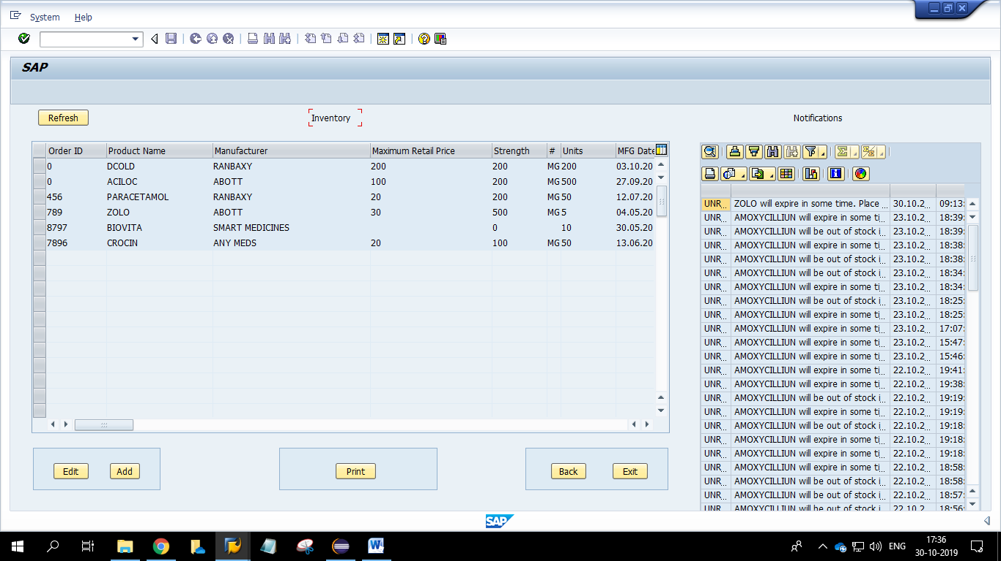

1. Adding to Inventory Screen: This screen has a form which can:

* Auto-generate ID for the entry.
* Add required details for the product.

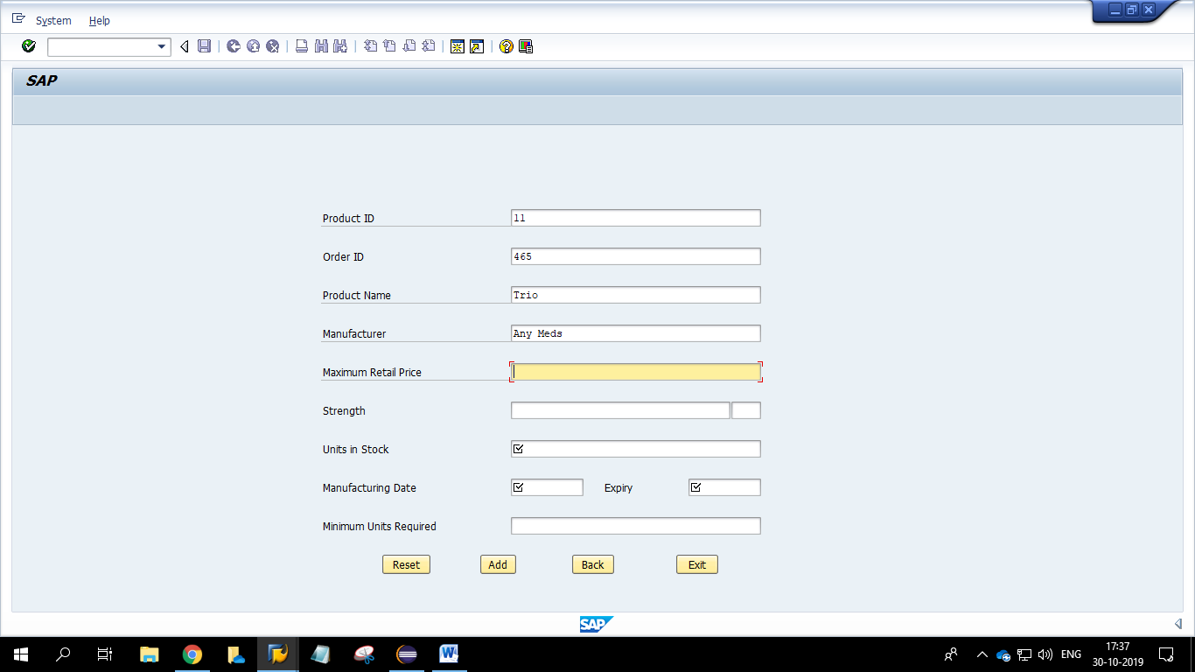

1. Editing an Inventory item: This screen has a form which can:

* Edit the details of the selected entry, except for the product id and order id.
* Update the details and re-edit the details as the edit button will be greyed out while updating and will be reactivated once update button is clicked and vice-versa.

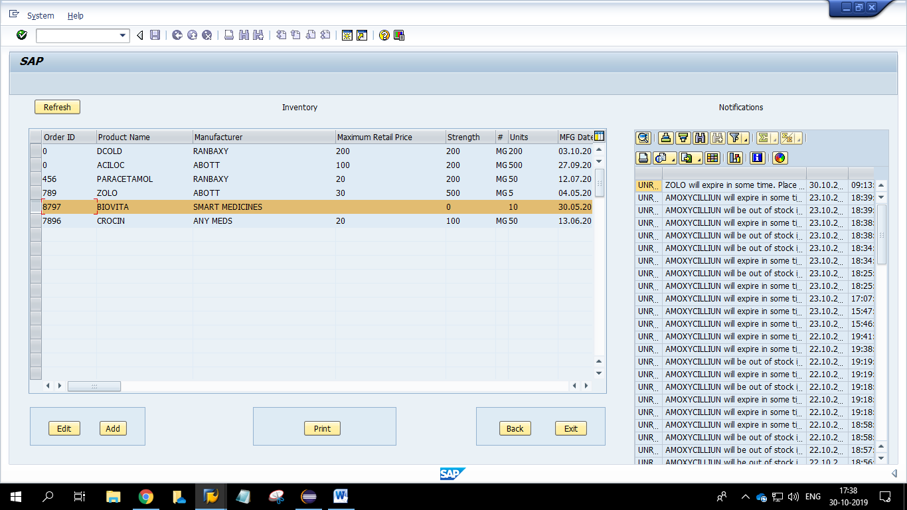

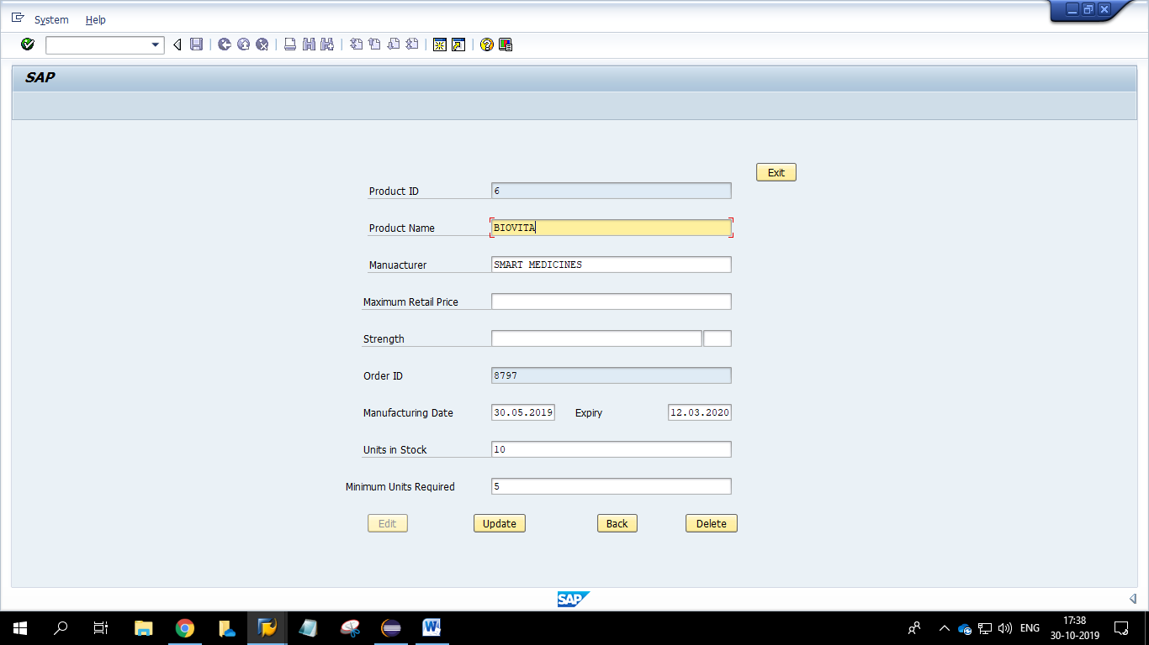

1. Notification Sub-screen: This sub-screen is displayed on the right hand side of the inventory screen :

* Displays notifications if any product is about to expire
* Displays notifications if any product’s number of units in stock is less than the minimum number set by the user.
* Displays the notification list as an OOALV.
* Double clicking on any item will display the notification in a pop-up box, in which upon clicking ok, the notification will be marked as read.

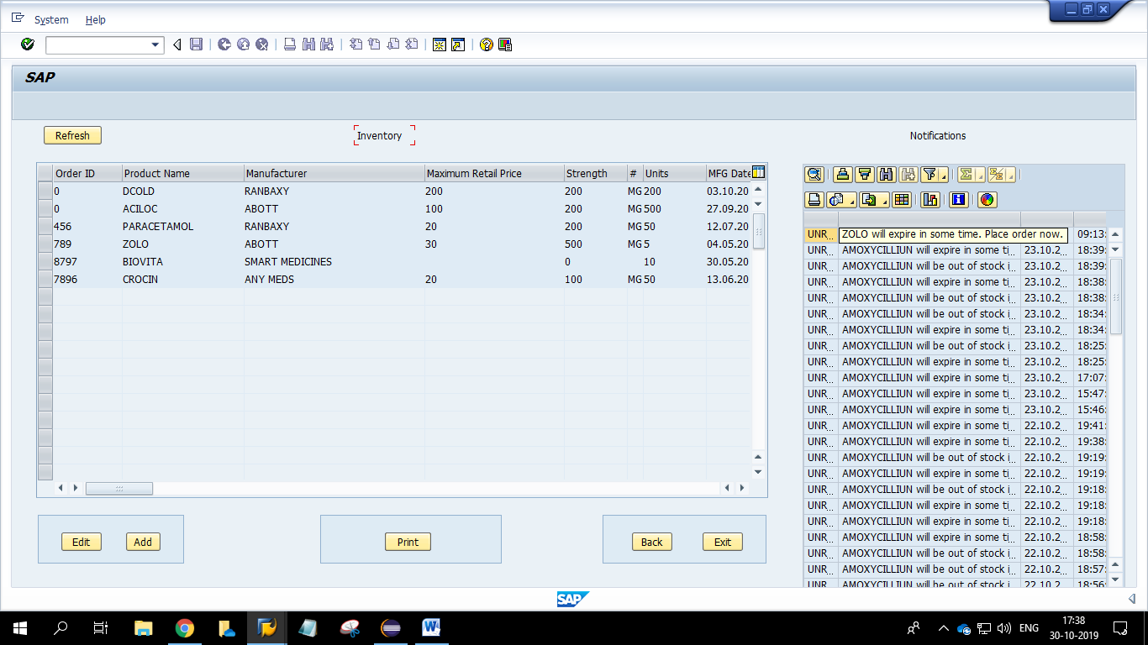

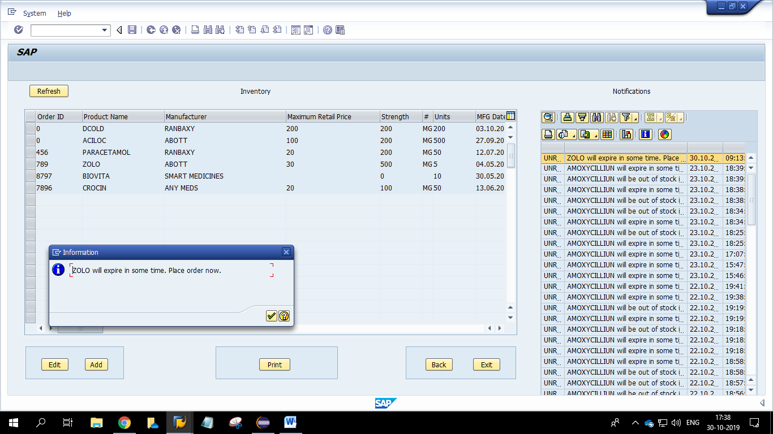

# Tables

1. Products Table

* Product-ID (key)
* Product Name
* Product Manufacturer
* Order Number (key)
* Maximum Retail Price
* Strength
* Unit of Strength
* Units in Stock
* Manufacturing Date
* Expiry Date
* Minimum Number of Units for generating alert

1. Notifications Table

* Notification-ID (key)
* Notification Text
* Notification Status (Read/Unread)
* Generation Date
* Generation Time